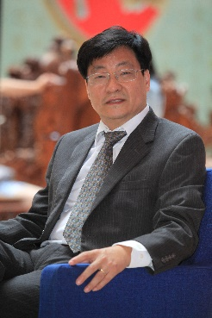
World Models for Robust Autonomous Driving in Mixed Traffic
Cheng-Zhong Xu
University of Macau, Macao SAR, China

Autonomous driving is transitioning into a mature phase focused on robustness, leveraging cognitive edge AI technologies. This talk will first discuss the challenges for robust autonomous driving in mixed traffic where self-driving and human driving vehicles co-exist. It will then introduce University of Macau’s MoCAD project, which develops core enabling technologies for robust autonomous driving in open and complex environments. Topics of generated AI for creating robust scenarios and world models for end-to-end driving simulation will be presented. Occupant emotional states and surrounding traffic behavior will also be discussed, as self-driving vehicles become moving robots on the road.

Dr. Cheng-Zhong Xu is a Chair Professor of Computer Science, the Dean of the Faculty of Information System and Computing, and the Director of Institute of AI and Brain Science, University of Macau. He served as Chief Scientist for key national projects on “Internet of Things for Smart City” (Ministry of Science and Technology of China) and “Intelligent Driving” (Macau SAR, China). He was also Director of Institute of Advanced Computing and Digital Engineering at the Shenzhen Institutes of Advanced Technology (SIAT), Chinese Academy of Sciences. Before these roles, he spent over 18 years as a faculty member at Wayne State University, USA. Dr. Xu's research focuses on parallel and distributed systems, cloud computing, intelligent driving and smart city applications. He has published over 600 papers and held more than 150 patents. His work has garnered over 27000 citations and has been cited in 340+ international patents, including 240 U.S. patents. Dr. Xu chaired IEEE Technical Committee of Distributed Processing from 2014 to 2020. He earned his B.S. and M.S. in Computer Science from Nanjing University and his Ph.D. from the University of Hong Kong in 1993. He is an IEEE fellow, due to contributions in resource management in parallel and distributed systems.

